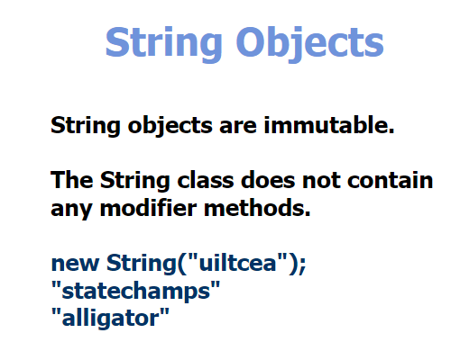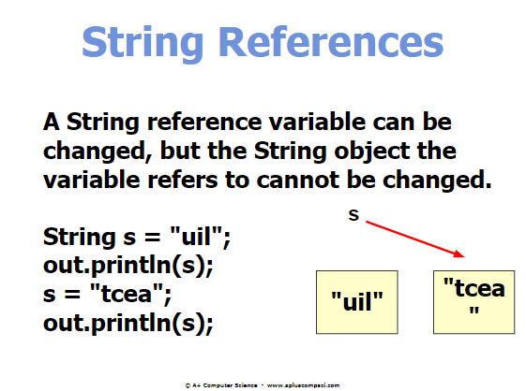

**Immutable = can NOT be changed

**For a string to change a value, you must **REASSIGN** the variable 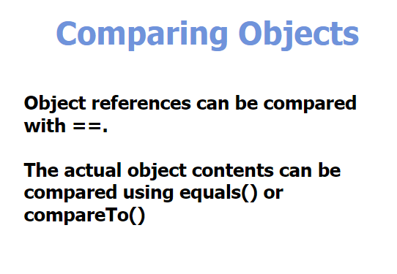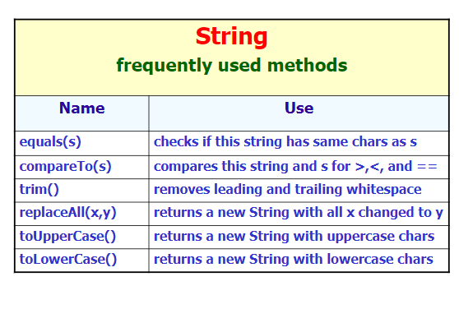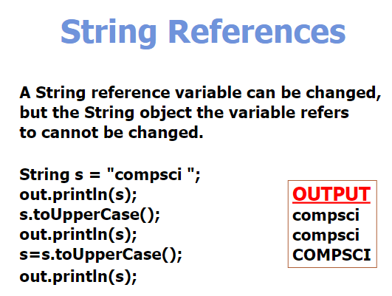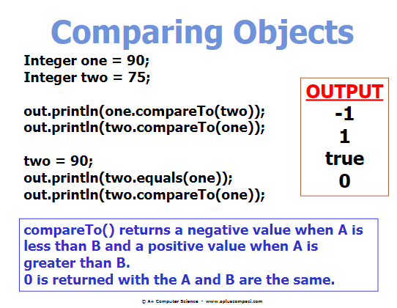

**\*\*when comparing two “Integer” Objects it will return: -1 if the 2nd is less than the first, +1 if the 2nd is above, 0 if they are the same.**

\*\***Integer.parseInt();** or **Double.parseDouble();** gives a numeric value of a string (BUT you can NOT have any spaces or letters within the inputted string just numbers) 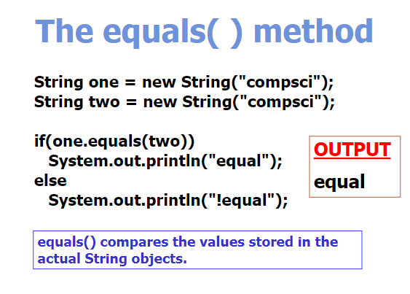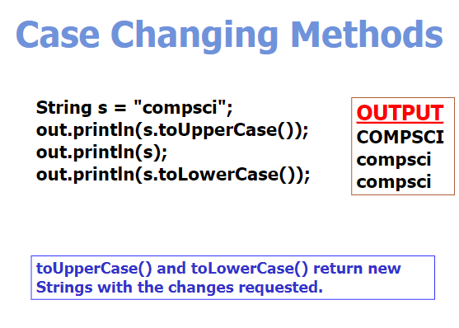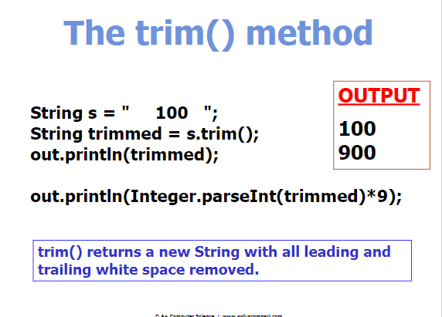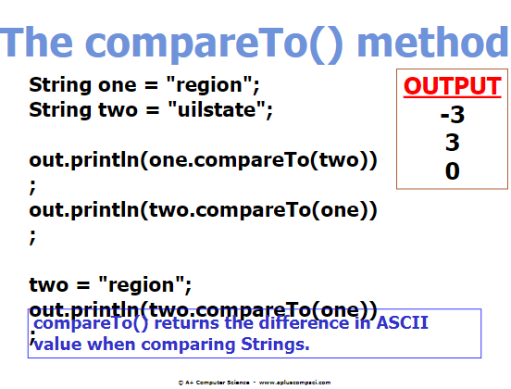

**When using X.parse.x(); you can use .trim(); to get rid off all white spaces

**compareTo(); compares the length when the strings are the same but one is longer than the other (returns the difference between the first letter and the second being compared)